Exercise 5: Resource Graph

Scenario

Azure Resource Graph is a service in Azure that is designed to extend Azure Resource Management by providing efficient and performant resource exploration with the ability to query at scale across all subscriptions and management groups so that you can effectively govern your environment.

For more details on Azure Resource Graph please visit [Resource Graph Overview](https://docs.microsoft.com/en-us/azure/governance/resource-graph/overview)

1. In the portal, click **All Services** and search for **Resource Graph Explorer (preview)**
2. Run a query that returns the number of Azure resources that exist in the Free Trial subscription  
   summarize count()  
   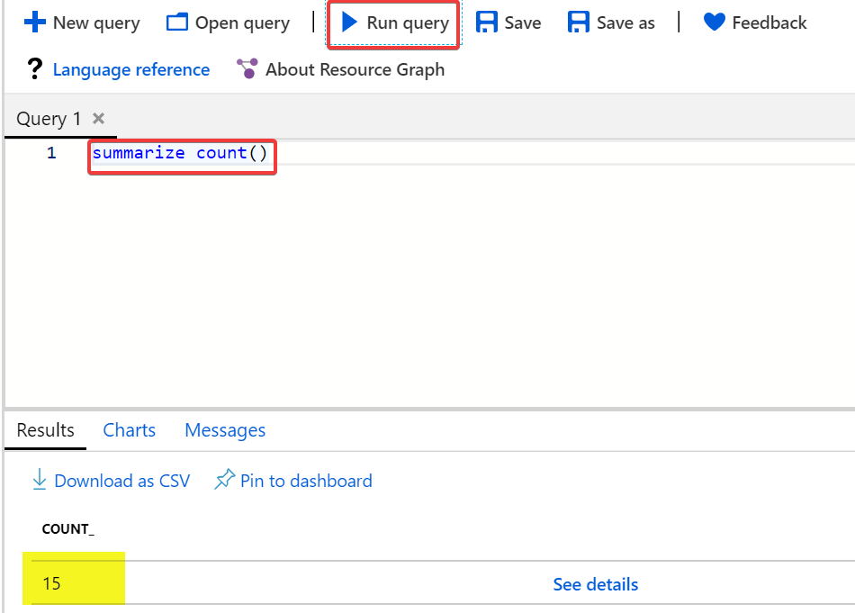
3. Run a query that returns any type of resource, but only the **name**, **type**, and **location** properties. It uses order by to sort the properties by the **name** property in ascending (asc) order  
   project name, type, location | order by name asc  
   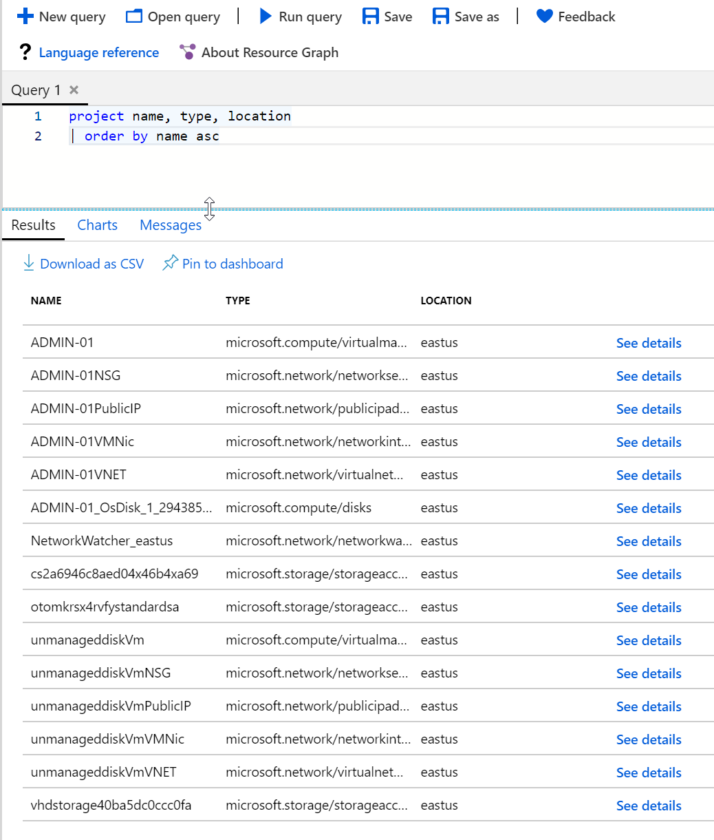
4. List the distinct values for Virtual Machine Size deployed in your subscription  
   summarize Count=count() by tostring(properties.hardwareProfile.vmSize)

| order by Count desc